**ConstantCurrentSupply - NPN**

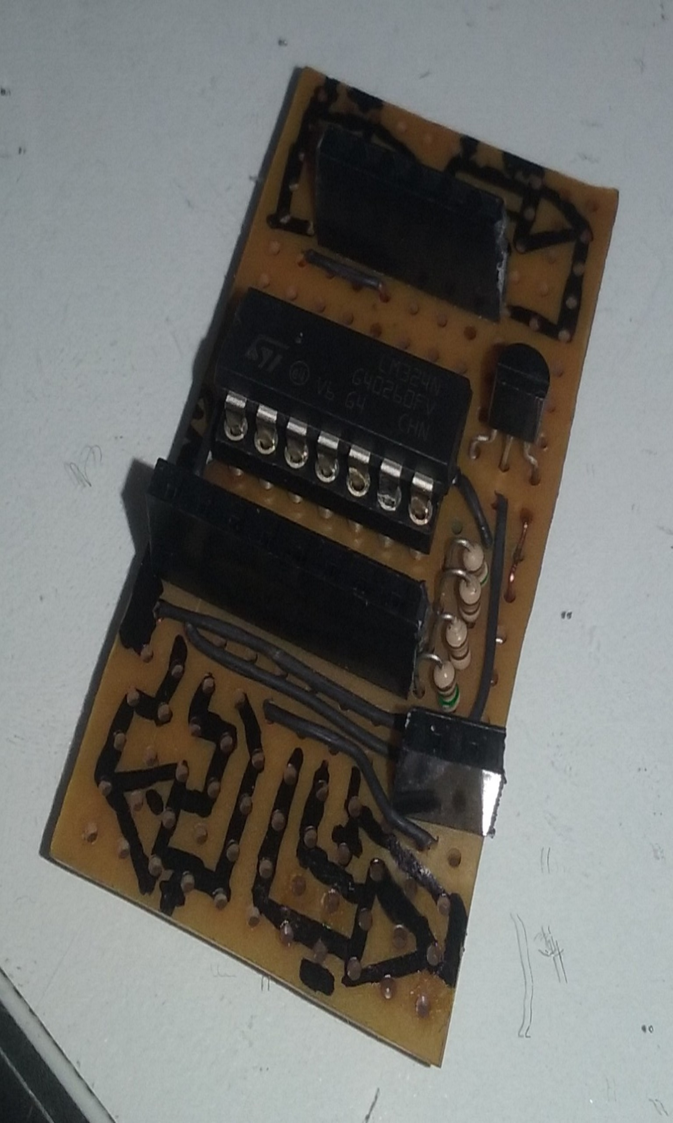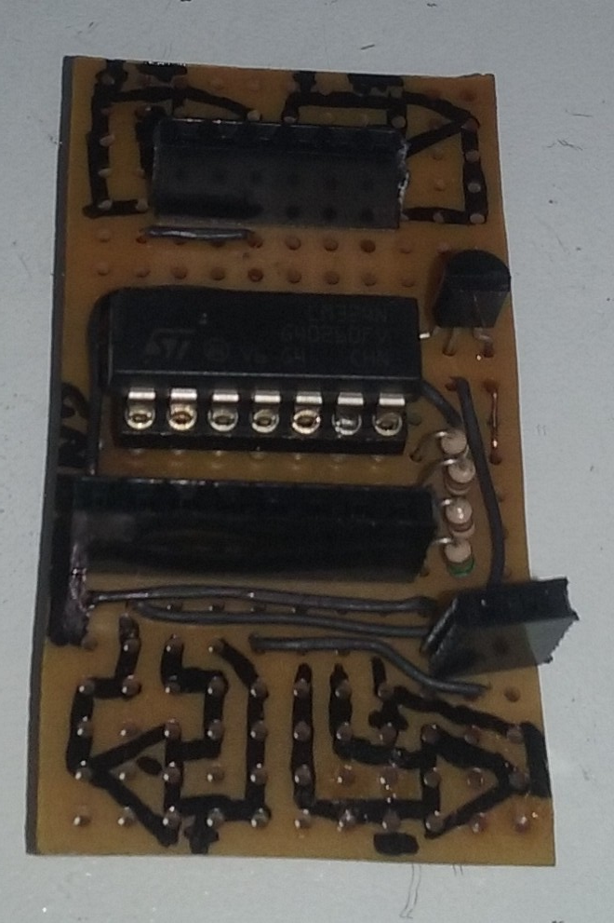

**V- C**

**Out D**

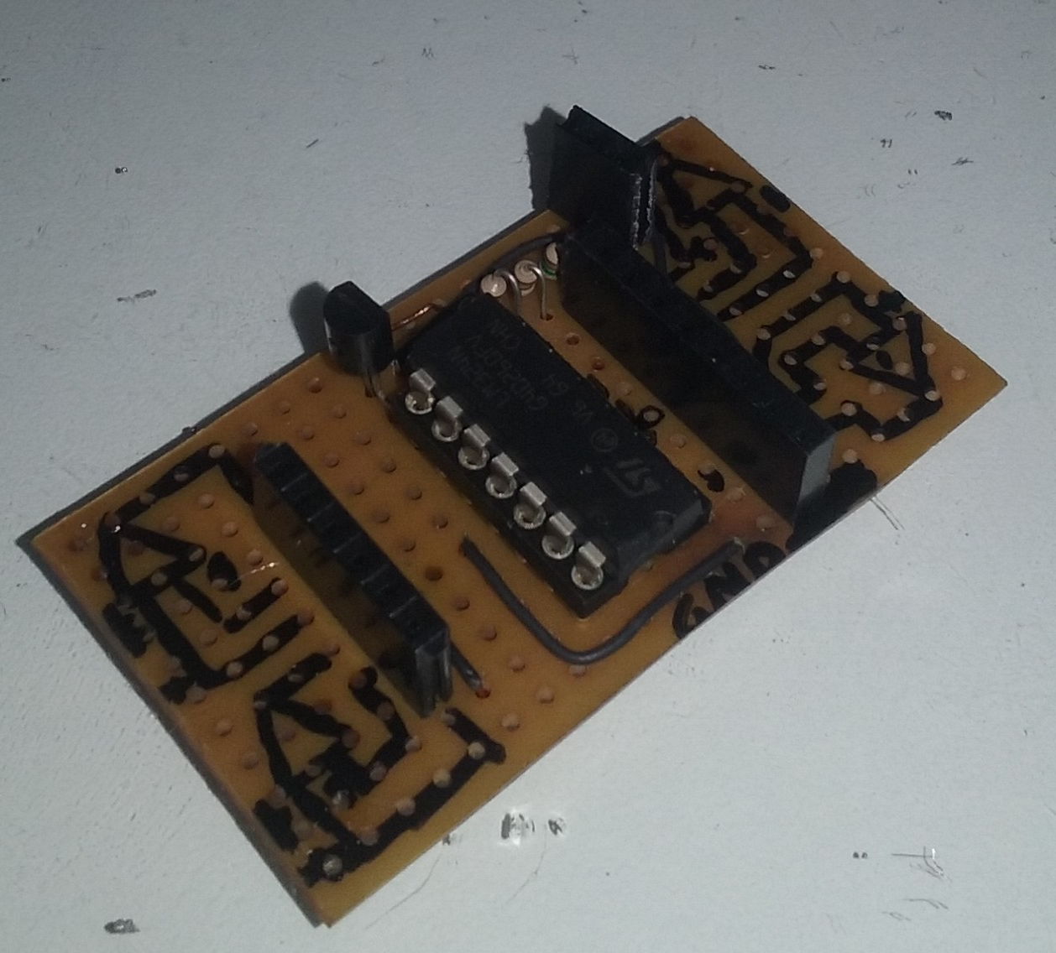

**Out C**

**V+ C**

**V+ D**

**V- D**

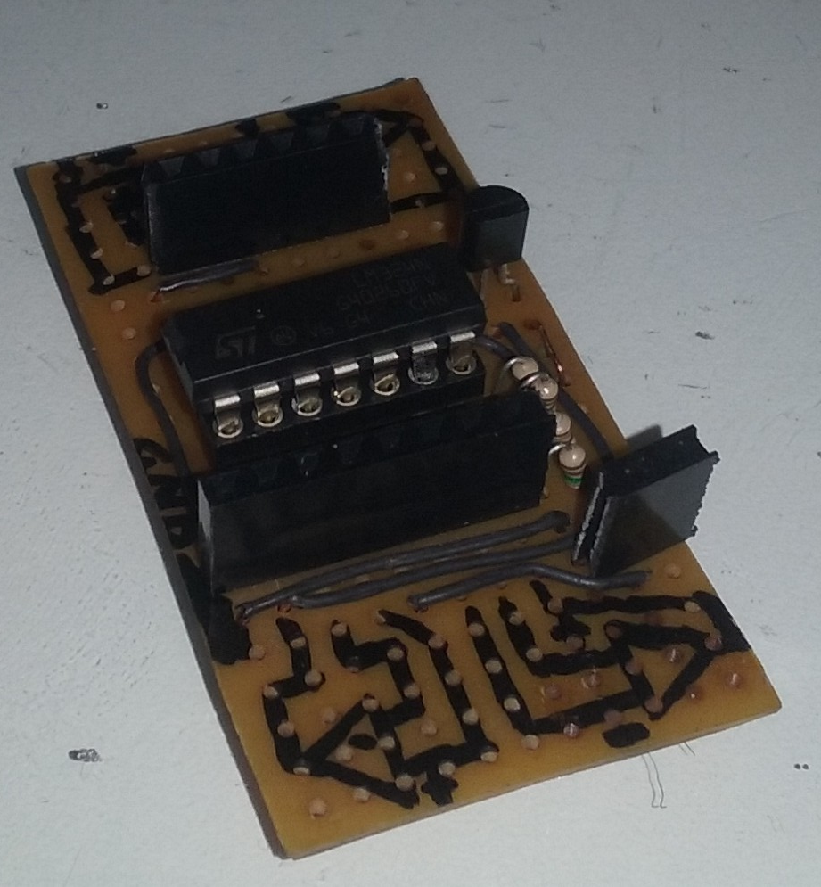

**Collector**

**VCC**

**Out B**

**V- B**

**V+ B**

**VCC**

**V+**

**V-**

**Out**

**GND**

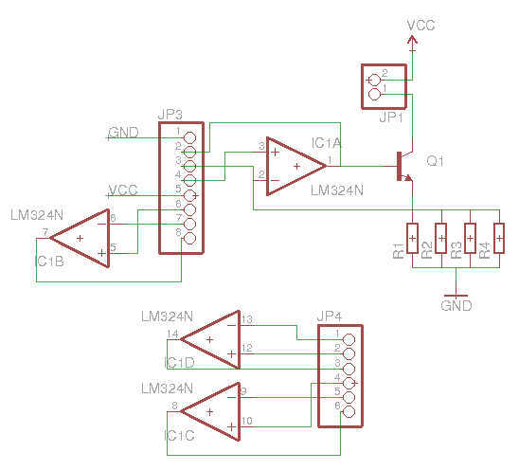

Use the 8-pin header to connect to a circuit. Pin-3 (V-) and pin-2 (Out) do not need to be used. Neither pins 6-8 (for the standard application).

The load should be connected to the two pin header.

Pins 6-8 are OpAmp B. the 6 pin header are OpAmp C and D.